Role of NGO in Rural Development

Prof. D. S. Jadhav

*Assistant Professor*

*Dr. SET’S Arts and Commerce College, Ugar-Khurd.*

[dsjadhav_comp@jspmrscoe.edu.in](mailto:dsjadhav_comp@jspmrscoe.edu.in)

*Abstract*: **In India, the scope of development is not narrow but very wide, as it includes not just the economic development but the growth on social front, quality of life, empowerment, women and child development, education and awareness of its citizens. To achieve this, a holistic vision and collaborative efforts involving various departments, agencies and even NGOs is required. NGOs or Non-Governmental Organizations have more benefits of working in rural areas as compared to governmental organizations because NGOs are more flexible, NGOs are specific to a particular locality and moreover these are committed towards serving the public and community as a whole.**

**Ⅰ. Introduction**

NGOs are difficult to define, and the term 'NGO' is rarely used consistently. As a result, there are many different classifications in use. The most common focus is on 'orientation' and 'level of operation'. An NGO's orientation refers to the type of activities it takes on. These activities might include human rights, environmental, or development work. An NGO's level of operation indicates the scale at which an organization works, such as local, regional, national or international. The term "non-governmental organization" was first coined in 1945, when the United Nations (UN) was created. The UN, itself an intergovernmental organization, made it possible for certain approved specialized international nonstate agencies—i.e., non-governmental organizations—to be awarded observer status at its assemblies and some of its meetings. Later the term became used more widely. Today, according to the UN, any kind of private organization that is independent from government control can be termed an "NGO", provided it is not-for-profit, non-criminal and not simply an opposition political party.

NGOs and Rural Development in India: In India, the scope of development is not narrow but very wide, as it includes not just the economic development but the growth on social front, quality of life, empowerment, women and child development, education and awareness of its citizens. The task of development is so huge and complicated that just implementing government plans is not sufficient to fix the problem. To achieve this, a holistic vision and collaborative efforts involving various departments, agencies and even NGOs is required. Owing to such a great need, the number of NGOs in India is increasing rapidly and, at present, there are about 25,000 to 30,000 active NGOs in India. Superficially, rural development seems to be a simple task but, in reality, it is not. Post- Independence era has seen many rural developments programmed through different five-year plans. Alleviating poverty, employment generation, more opportunities for generating income, and infrastructure facilities are emphasized through the policies of the government. Along with this, the panchayat raj institutions have also been initiated by the government to strengthen the democracy at grass roots level. But in spite of all the efforts rural poverty, unemployment rate, low production still exists. The fight is still on for the basic facilities such as livelihood security, sanitation problem, education, medical facilities, roads, etc. Still there is a huge gap in terms of infrastructure that is available in urban and rural areas. The basic rural development should include all these apart from employment, proper water supply and other basic facilities. NGOs or Non-Governmental Organizations have more benefits of working in rural areas as compared to governmental organizations because NGOs are more flexible, NGOs are specific to a particular locality and moreover these are committed towards serving the public and community as a whole. As the task of development is massive, many NGOs are playing vital role in the rural development of India in collaboration with the government.

**Ⅱ. NGOs in India:**

Since ancient times, social service has been an integral part of Indian culture. Soon after Independence, a number of NGOs had emerged in India. Mahatma Gandhi even pleaded to dissolve the Indian National Congress and transform it to a Lok Seva Sangh (Public Service Organization). Though his plea was rejected, but the followers of Mahatma Gandhi started many voluntary agencies to work on various social as well as economic issues of the country. This was the first phase of NGOs in India. The second phase of NGO development started in 1960 when it was felt that just the government programs were not sufficient to complete the task of development in rural areas. Many groups were formed whose role was to work at grass root levels. Moreover, favorable state policies had drastically affected the formation of NGOs and their roles at that time. Over the years, the role of NGOs in rural development of India increased. At present too, their role significantly changes with the change in the policies of the government through different plans. In the sixth five-year plan (1980-1985), a new role for NGOs in the rural development had been identified by the government. In the seventh five-year plan (1985-1990), the Indian government envisaged an active role of NGOs in developing self-reliant communities. These groups were supposed to show how the village resources along with human resource, skill, local knowledge that is greatly underutilized could be used for their own development. As NGOs were working in close connection with local people so bringing such a change was not a tough task for them. Owing to this, in the eighth five-year plan, more importance to NGOs for rural development in India had been given. Under this scheme, a nationwide NGO network had been created. The role of these agencies was the rural development at a low cost. In the ninth five-year plan, it has been proposed that NGOs would play a significant role in the development on the public-private partnership model. More scope has been provided to NGOs by the government for rural development through the agricultural development policies as well as their implementation mechanisms. As with every five-year plan, the role of NGOs in the rural development of India is growing, so NGOs are now attracting professionals from different fields. NGOs act as planners and implementers of developmental plans. They help in mobilizing the local resources to be used for development. NGOs help in building a self-reliant and sustainable society. These agencies play the role of mediator between people and government. NGOs are actually the facilitator of development, education and professionalization.

**Ⅲ. Hurdles in the way to rural development:**

A major problem that NGOs are facing in India is their dependency upon government funds or external donations. With this dependency, NGOs are less flexible in carrying out their task as most of the tasks depend upon funds. Moreover, the structures of NGOs have become bureaucratic in nature leading to a decreased effectiveness in the overall development. Then the traditional thinking of rural people, their poor understanding, and low level of education for comprehending new technology and efforts, lack of awareness are people related hurdles that NGOs are facing. Villages also lack infrastructure facilities like water, electricity, educational institutes, communication facilities that leads to their slow development. Apart from these, there are certain problems like economics such as high-cost technology, underprivileged rural industries, social and cultural differences, conflicts between different groups, administrative problems like political interference, lack of motivation and interest act as hurdles on the way to rural development in India. But in spite of all the hurdles, NGOs will keep on working for rural development in India. NGOs selectively utilized the local talent, train the individuals and use this for rural development. But the complete success of the rural development actually depends upon the willingness and active participation of rural people in the development processes and efforts.

In operational context the major issues facing by the NGOs are the lack of qualified individuals who would like to work in the rural areas. Another major problem that NGOs are facing in India is their dependency upon government funds or external donations. With this dependency, NGOs are less flexible in carrying out their task as most of the tasks depend upon funds. Moreover, the structures of NGOs have become bureaucratic in nature leading to a decreased effectiveness in the overall development. Then the traditional thinking of rural people, their poor understanding because of high rate of illiteracy for comprehending new technology and efforts, lack of awareness among people related hurdles that NGOs are facing. Villages also lack infrastructure facilities like water, electricity, educational institutes, communication facilities that leads to their slow development. 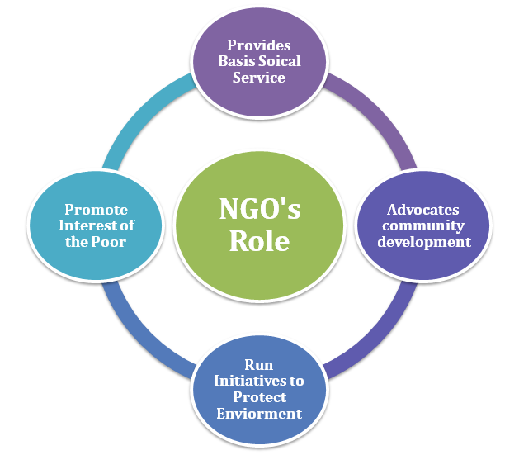

Fig.1 Role of NGOs in Rural Development

**Major role seen for NGOs in rural development:** As economic reform and liberalization saw the Government vacating several areas to let private sector entrepreneurship flourish and contribute to the high growth rate of the economy in recent years, a similar paradigm shift is needed to transform NGOs from their dependence on aid and grants from within and outside for transforming the rural scenario in the country. This is sought to be achieved for the NGOs through engaging them in micro-finance, micro insurance, and micro-entrepreneurship activities for the overall development of the rural areas and to promote the welfare of the people of rural India, Better credibility: As NGOs get finance generated through their own activities. Their credibility vastly improves and their service to rural people gets reinforced. CNRI is an apex body with over 2,000 member NGOs engaged in multifarious activities ranging from self-help group formation, income generation, marketing, and agency work for insurance companies for life and non-life products and for banks and financial institutions to environment protection, watershed management, handicrafts, textiles, traditional medicinal plants and HR development. It is completing one year of its existence. To mark the celebration of one year of its service to NGOs, CNRI is hosting a three-day national meet - `Advantage Rural India' - from April 17.

**Conclusion:** In this way the NGO’s can bring the awareness among the poor rural people. It is now the need of the society as well as the nation to make these rural area and people competent to be aware about their fundamental rights. NGO’s are the only organizations that could make the rural area developed.